**LAB RECORD**

**Compiler Design**

**19CSE401**



**BONAFIDE CERTIFICATE**

**University Reg. No** : CH.EN.U4CSE22160

This is to certify that this is a bonafide record work done by

Mr. / Miss. Velchuri Sarvan studying B.Tech CSE 4th year.

**Internal Examiner1 Internal Examiner2**

**Index**

|  |  |  |
| --- | --- | --- |
| **Experiment No** (LAB) | **Title** | **Page No** |
| 01 | Implementation of Lexical Analyser using Lex Tools | 4-8 |
| 02 | Program to eliminate left recursion and factoring from t the given grammar | 9-11 |
| 03 | Implementation of LL(1) Parsing | 12-14 |
| 04 | Parser Generation Using YACC | 15-17 |
| 05 | Implementation of Symbol Table | 18-19 |
| 06 | Implementation of Intermediate Code Generation | 20-21 |
| 07 | Implementation of Code Optimization Techniques | 22-24 |
| 08 | Implementation of target code generation | 25-26 |

**Lab Exercise -01**

**1. Aim**: To write a program that identifies and counts words in an input sentence.

**Program:**

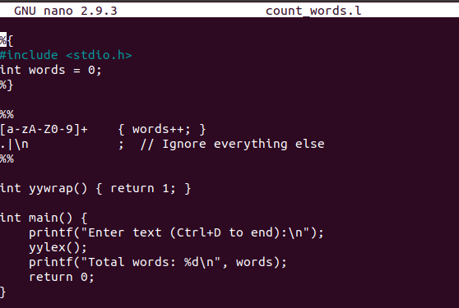

**Output:**

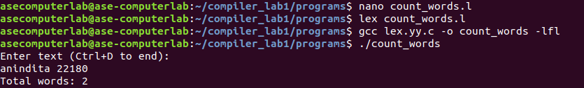

**2. Aim**: To write a program that checks whether a given number is odd or even.

**Program:**

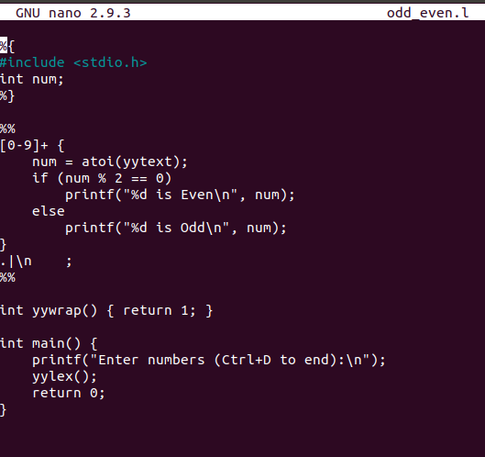

**Output:**

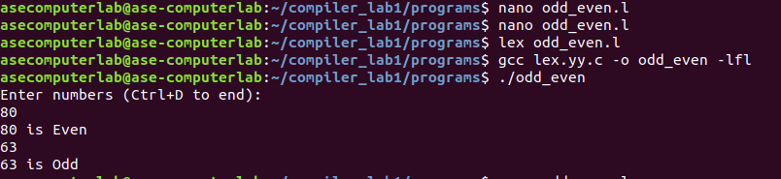

**3. Aim**: To write a program that identifies and counts vowels in each character or string.

**Program**:

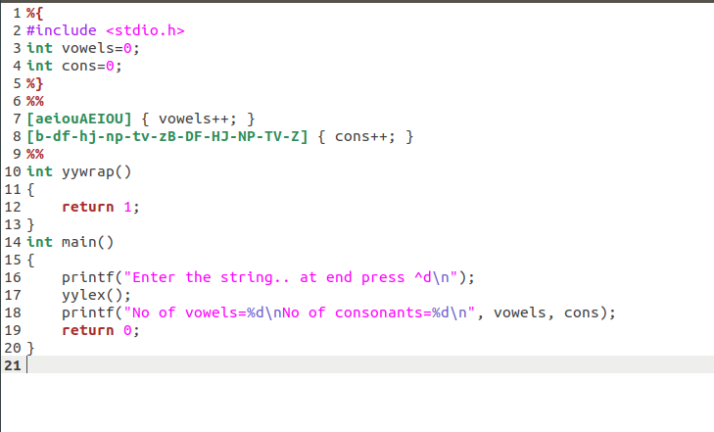

**Output:**

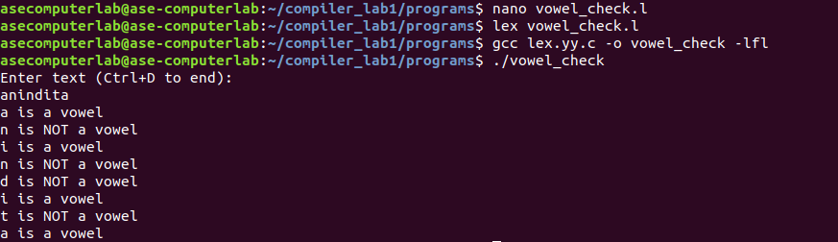

**4. Aim**: To write a program that determines whether a given number is positive or negative.

**Program:**

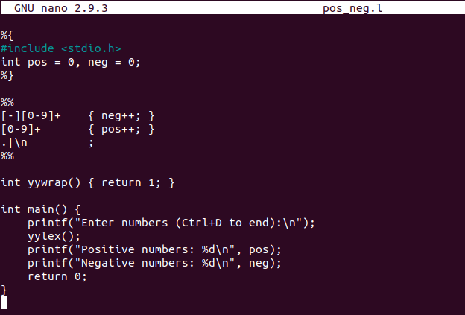

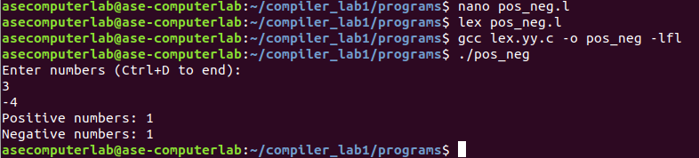**Output**:

**5. Aim:** To write a program that calculates the sum of the digits of a given number.

**Program:**

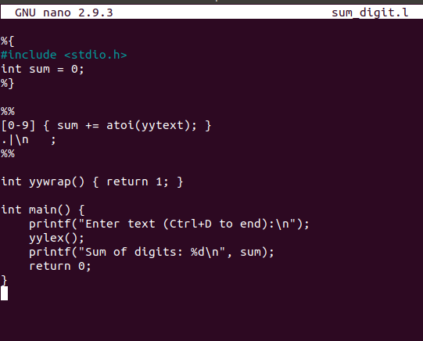

**Output**:

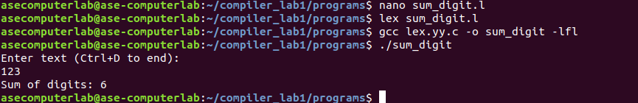

**Results**: The programs for Implementation of Lexical Analyzer using Lex Tools

has been successfully executed.

Lab Exercise -02

**Aim**: To implement eliminate left recursion and left factoring from the given grammar using C program.

**Left factoring**

**Code:**

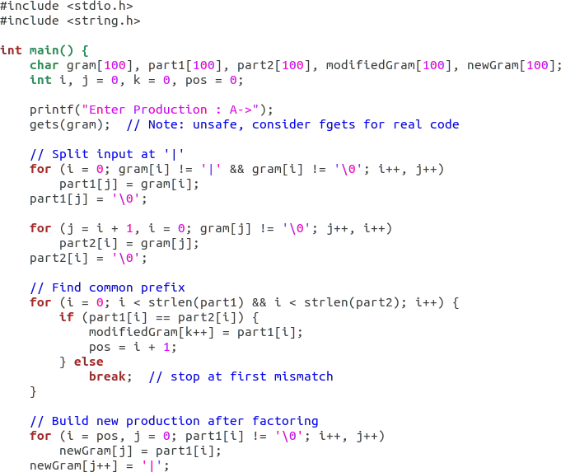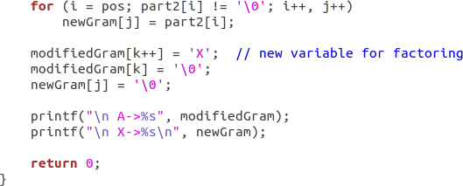

**Output:**

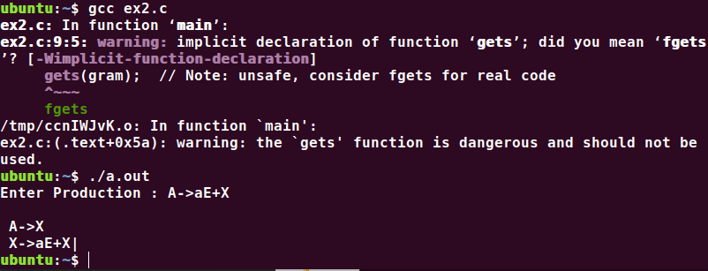

**Left Recursion**

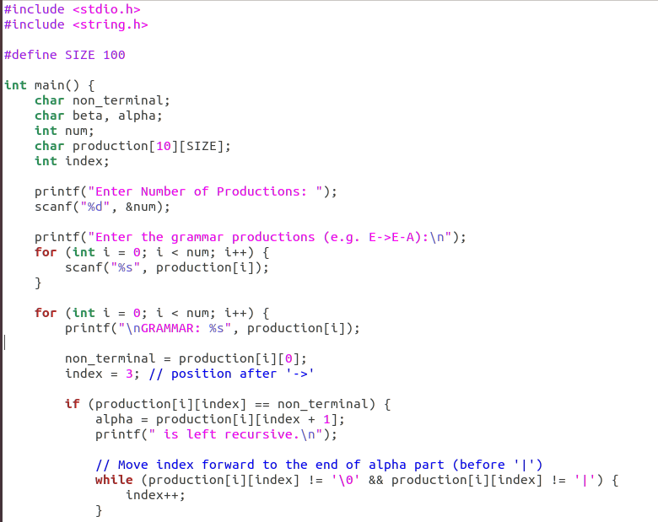 **Code:**

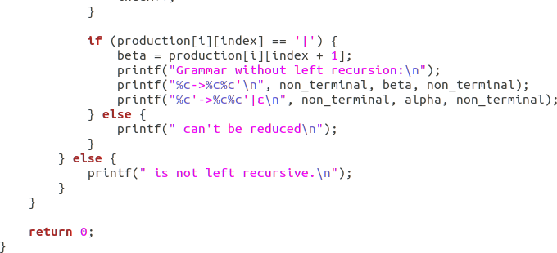

**Output:**

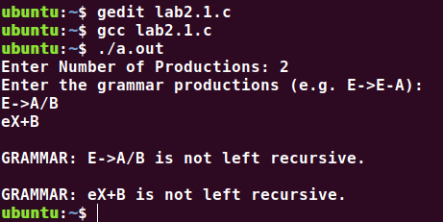

**Results**: The program to implement left factoring and left recursion has been successfully executed.

**Lab Exercises - 03**

**Aim**: To implement LL(1) parsing using C program.

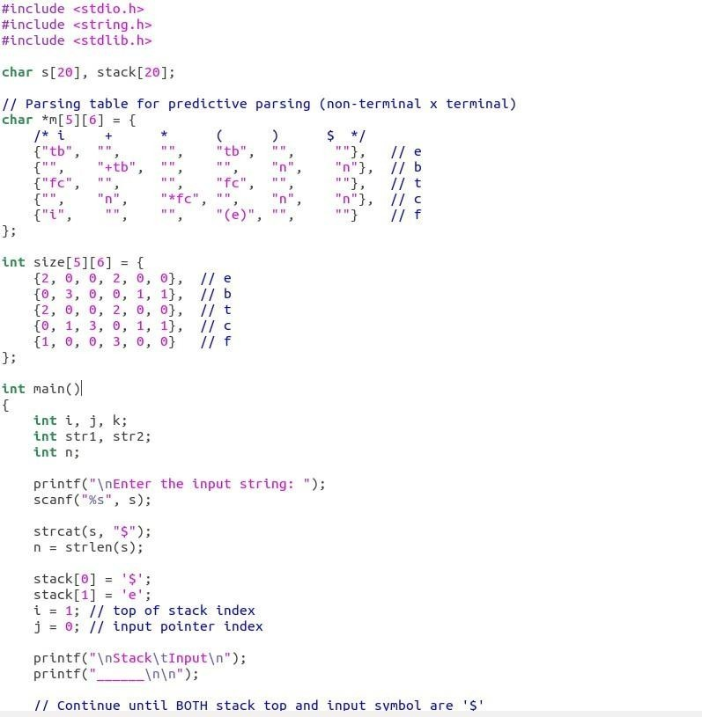 **Code:**

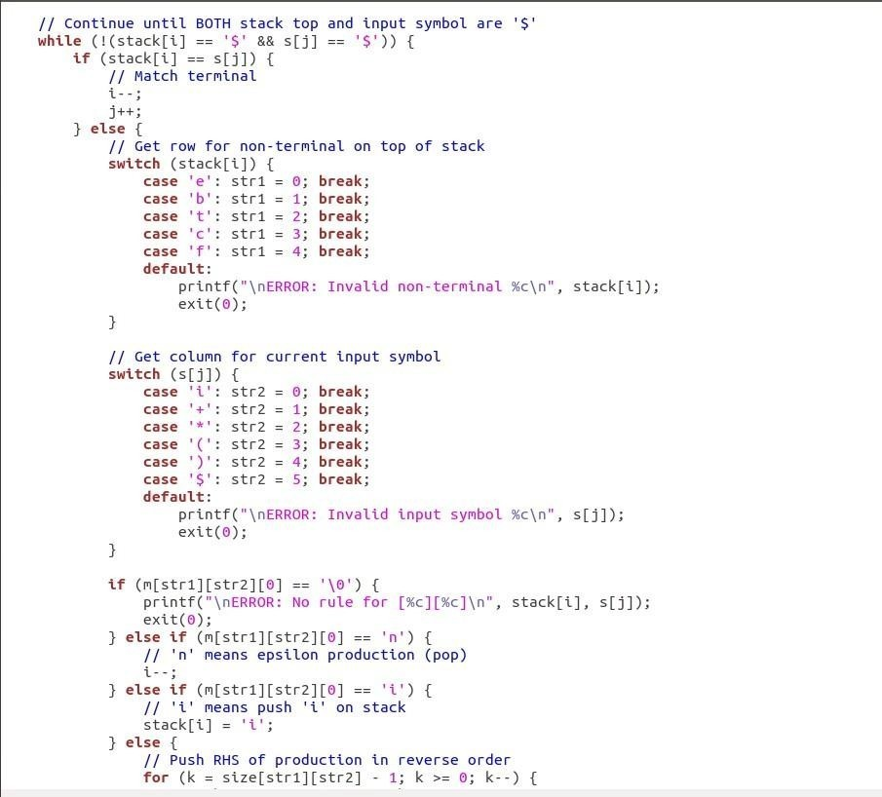

**Output:**

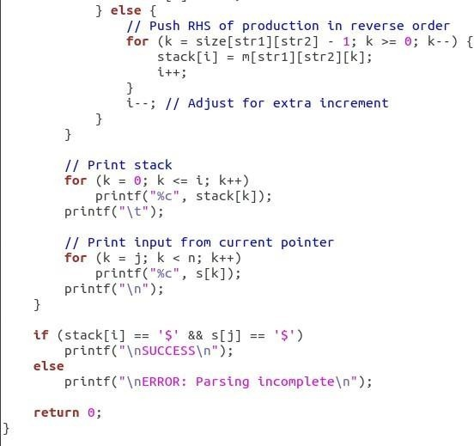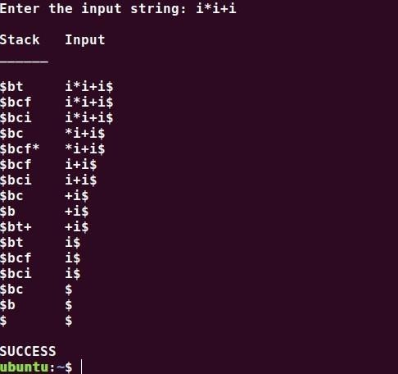

**Results**: The program to implement left factoring and left recursion has

been successfully executed.

**Lab Exercises -04**

**Aim**: To write a program in YACC for parser generation.

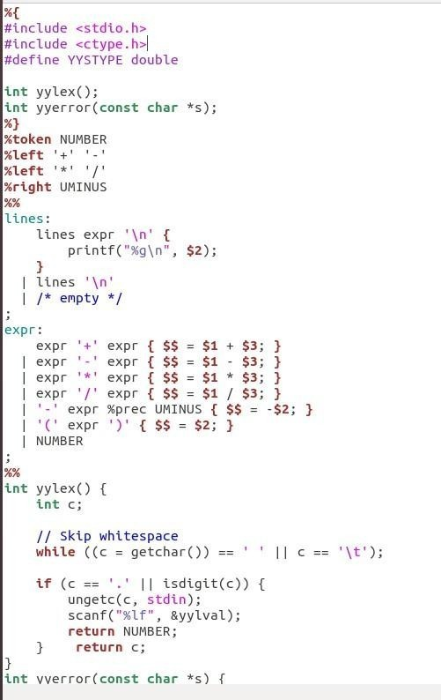 **Code**:

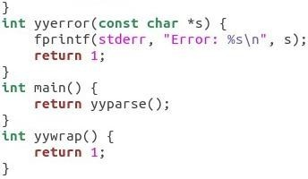

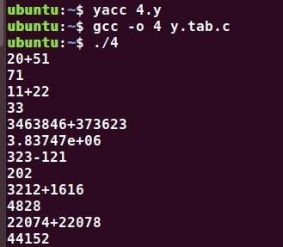**Output:**

**Results:** The program in YACC for parser generation has been executed successfully

**Lab Exercise- 05**

**Aim:** To Implement Symbol Table

**Code:**

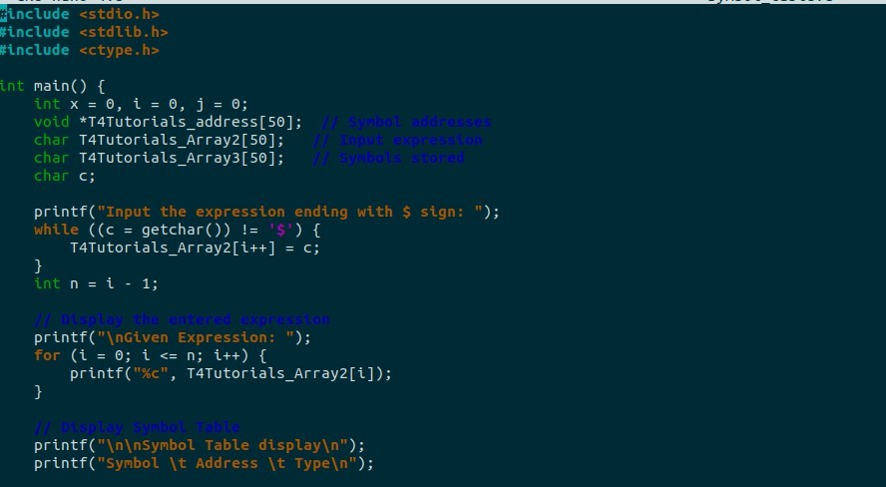

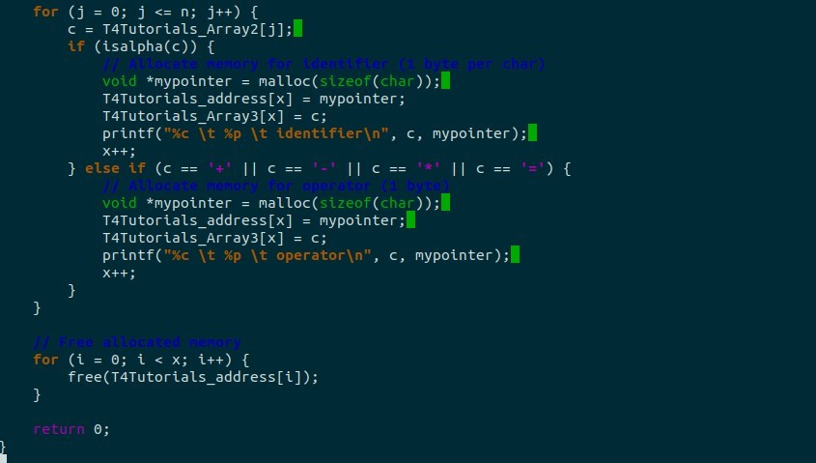

**Output:**

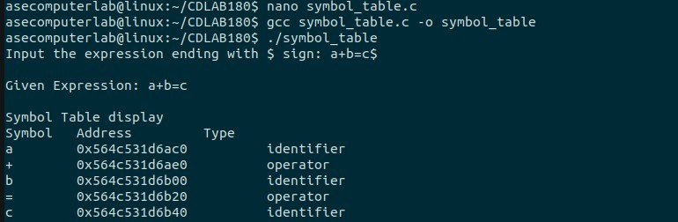

**Result:** Thus, the program to implement symbol table has been executed successfully.

**Lab Exercise- 06**

**Aim:** To Implement Intermediate Code generation

**Code:**

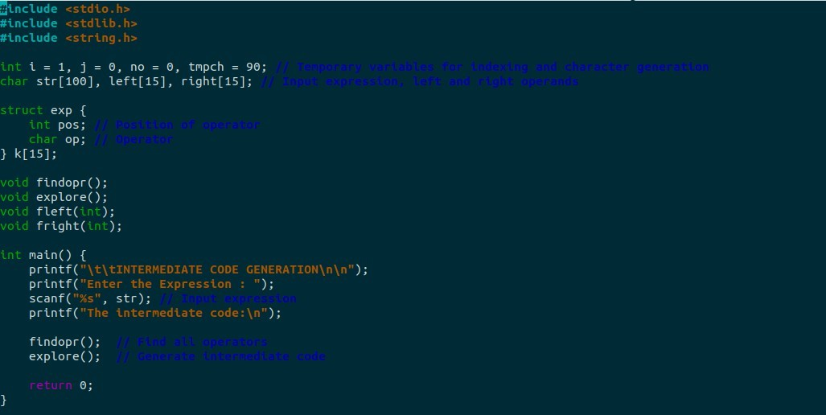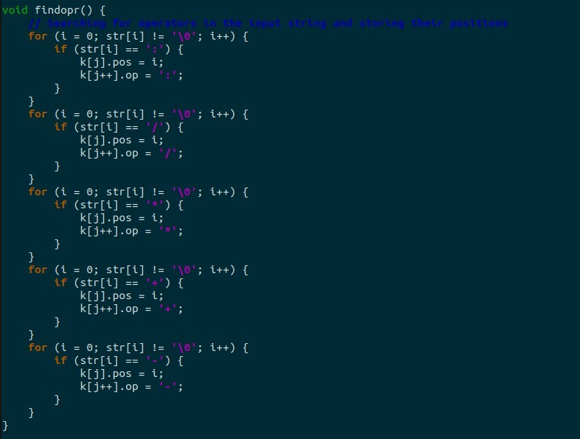

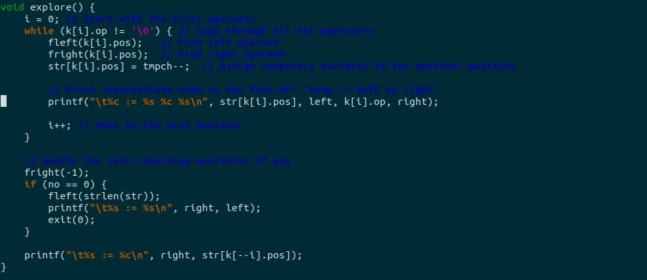

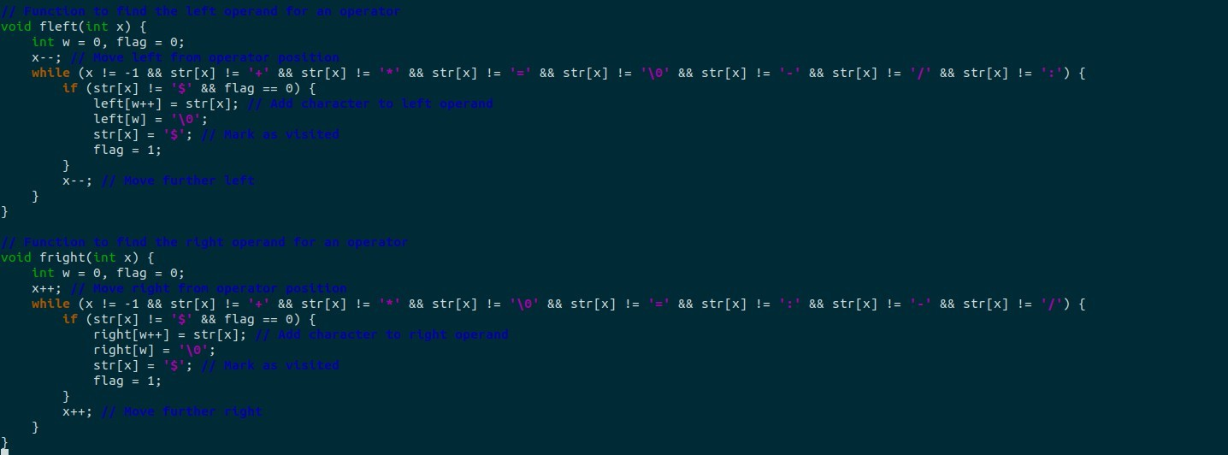

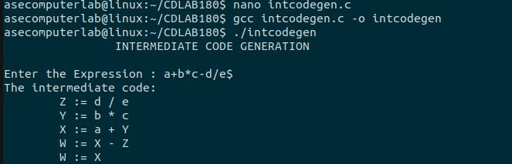**Output:**

**Result:** Thus, the program to implement intermediate code generation has been executed successfully

**Lab Exercise- 07**

**Aim:** To implementation of Code Optimization Techniques

**Code:**

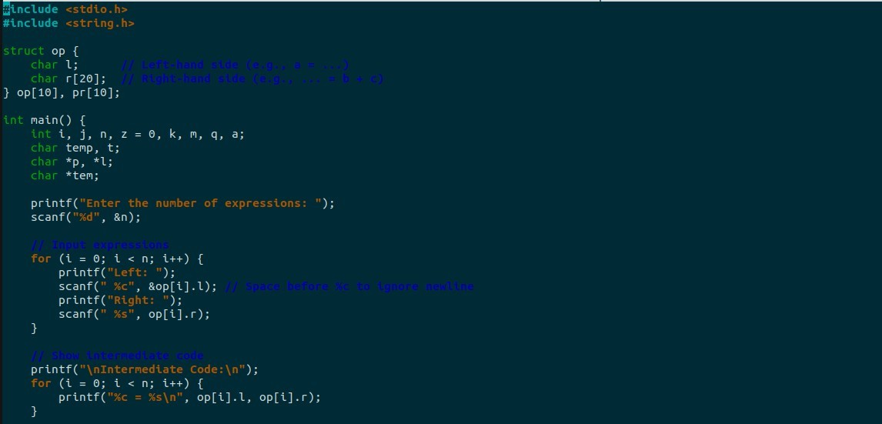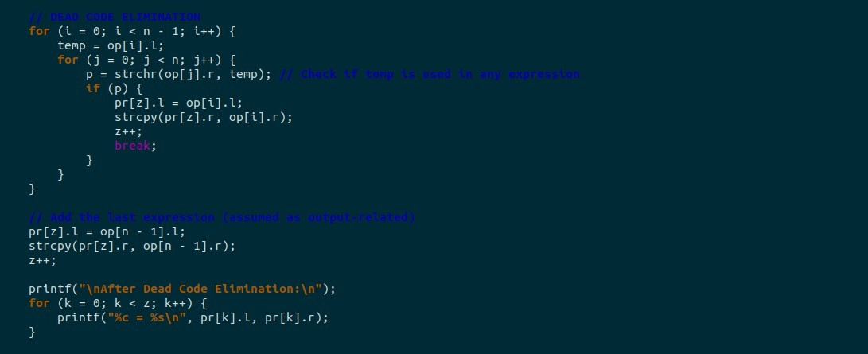

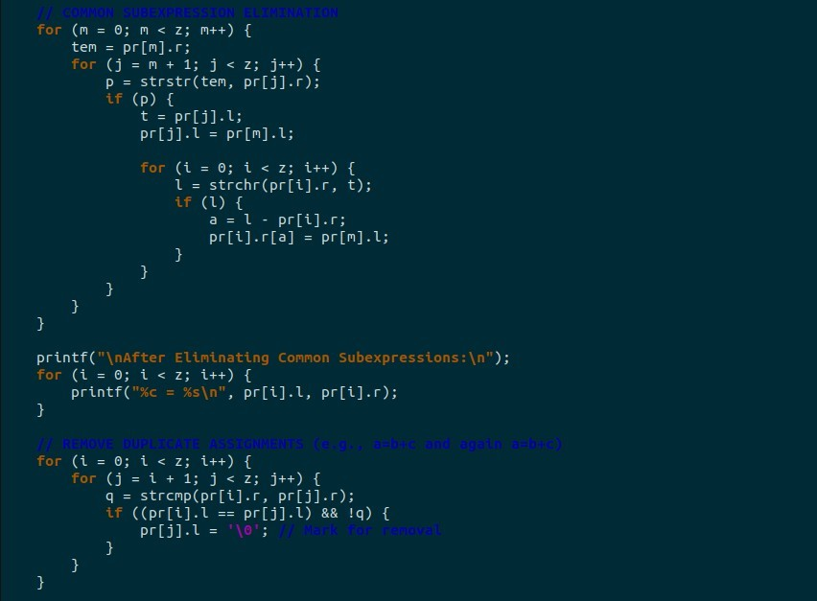

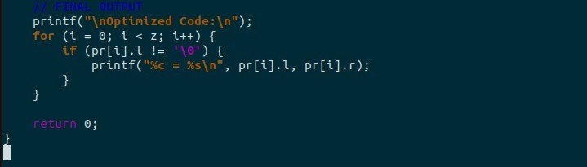

**Output:**

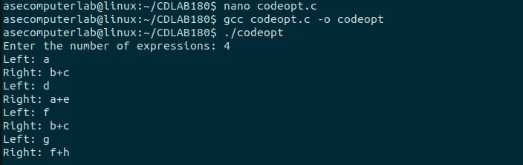

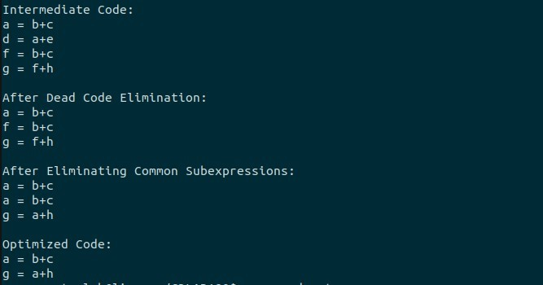

**Result:** Thus, the program to implement code optimization has been executed successfully

**Lab Exercise- 08**

**Aim:** To write a program that implements the target code generation

**Code:**

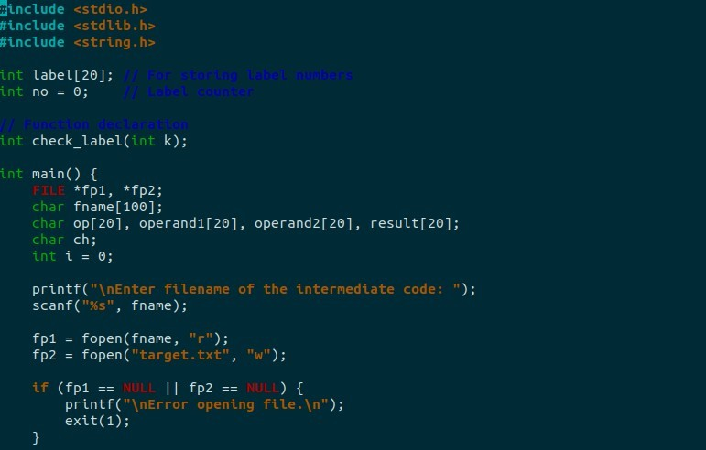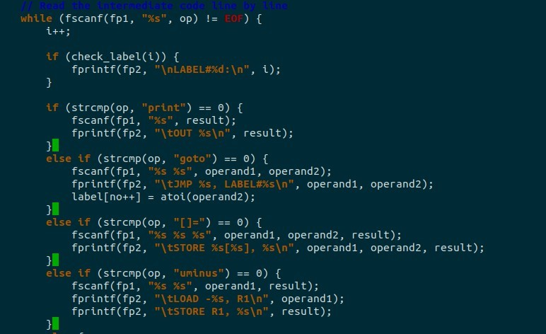

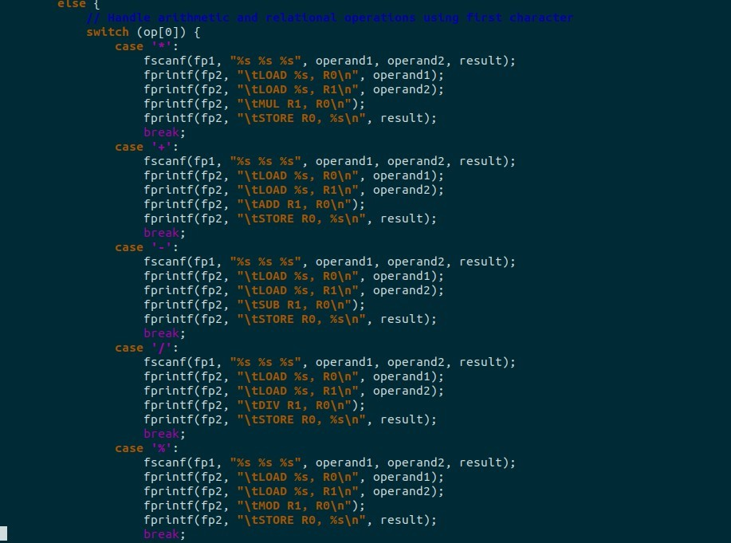

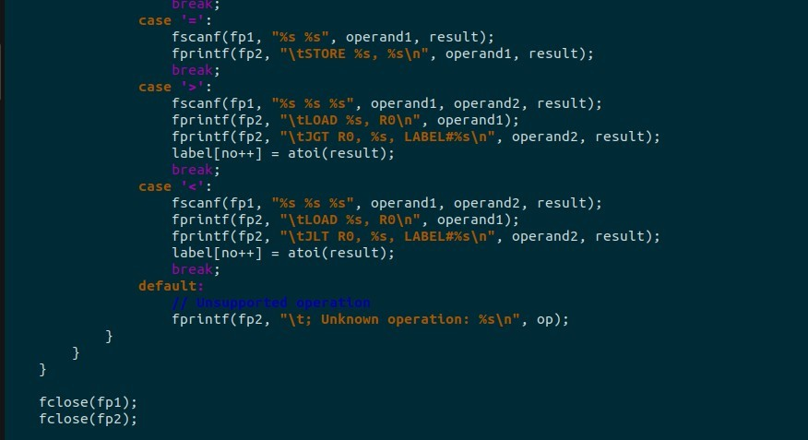

**Input.txt**

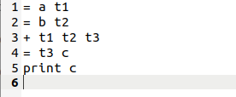

**Output:**

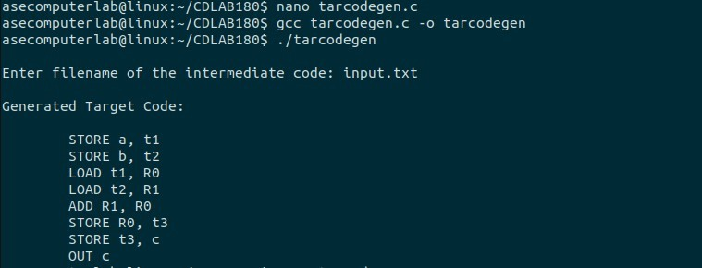

**Result**: Thus, the program to implement target code generation has been successfully

executed